**Traceability Process Data.**

**Station configuration**

1. Station Name (Asigned by IT)

-Example: STA_FNLFUNC123

1. Process Name Station according with the Process Flow.

- Example: TEST FINAL FUNCTIONAL

1. Model and Product Revision according with the Traceability System

-Example: 2H24480+G

**This section should be for all UUTs.**

1. **Scan the Serial Number from label.**

Use this function from DLL

CIMP_PartNumberRef

**Arguments**

SerialNumber (string): Serial Number from Label.

BCTYPE (int) = 1

AssemblyPartNumber (ref string) = reply function, PartNumber of PCB

If the return value is equal is valid, continue

1. **Backcheck to Tracability Data Base.**

Use this function from DLL:

“BackCheck_Serial()”

**Arguments**

_SerialNumber (string): Serial Number from Label.

_stationName (string): Station Name

**Return Value**

-Return Value (string): answer from Traceability System

Expected string (for Functional Test) : “1|TEST FINAL FUNCTIONAL”

If the return value is equal to Expected String continue with the Test Sequence.

If the return value if different from the Expected String the information returned in the “Return Value” will be displayed in the screen for the Operator acknowledge and the Test Sequence shall not continue. Remove the UUT.

1. **Request the start time (initial).**

Use the Function “Cimp_GetDateTime Str” for request the day and time when you start the Test Sequence (before to the first test step)

1. **Do the Test Sequence for the UUT.**
2. **Request the Final time.**

Use the function “Cimp_GetDateTimeStr” for request the day and time when you finish the Test Sequence (after last test step).

1. **Send the Test Results to the Traceability System.**

Use the Function “InsertProcessDataWithFails” (for both Results PASS or FAIL)

**Arguments:**

- ser_num (string): Serial Number from Label.

- station_name (string): Station Name from the Tester Config.

- function (string): Test Process Name from backcheck (Step #2)

- ent_time (string): Start Time from Step #4

- ext_time (string): Final Time from Step #6

- pass_fail (integer): Result of the Test Sequence (0=FAIL, 1=PASS)

- fail_string (string): Empty if the Test Result is PASS or String with the Fail information (syntax without ("): "|ftestres=0,test_name,test_measurement,HighLimit,LowLimit,ExpectedValue,units,logic_operator"

- employee (string): Employee number

Return Value must be evaluated. Expected return value= “OK”

1. **End.**

**Note**

**You can’t Access two Functions at the same time from the DLL.**

**If the Fixture has 2 or more nests you need to synchronize the sequence for call function one by one.**

**MACRO PROCESS FLOW**

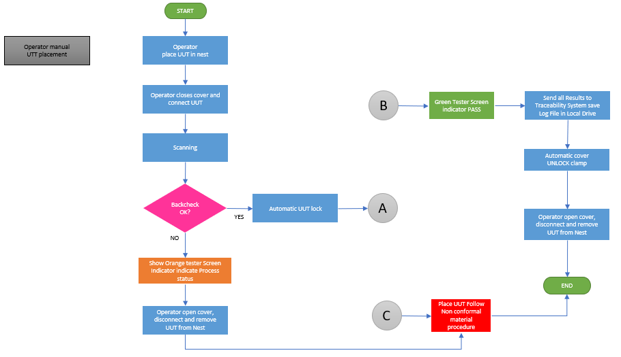

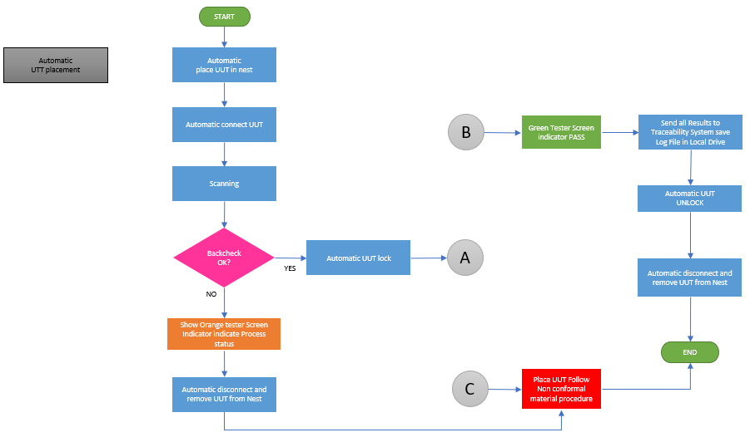

**Traceability Process Flow and Re-Test Failure UUTs**

